**Lab 09**

Submitted by**:**

**Maaz Habib**

Registration Number**:**

**20PWCSE1952**

Section:

**C**

Submitted To**:**

**Dr. Muniba Ashfaq**

January 31, 2024

**Department of Computer System Engineering**

**University of Engineering and Technology Peshawar**

**Task1:**

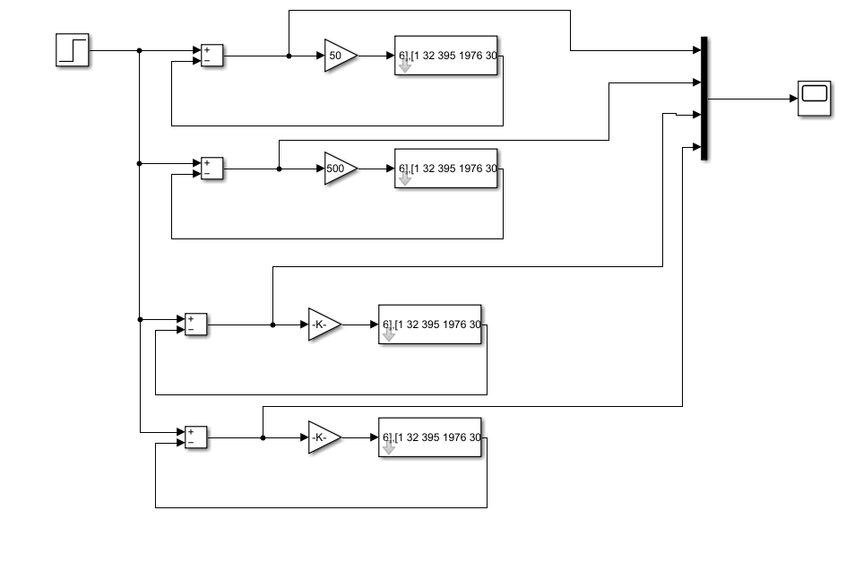

**Result:**

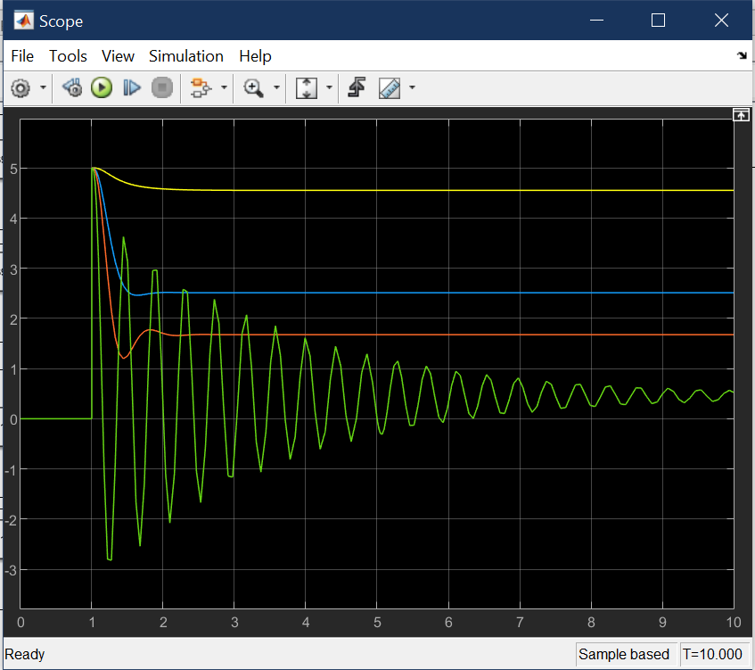

**Task2:**

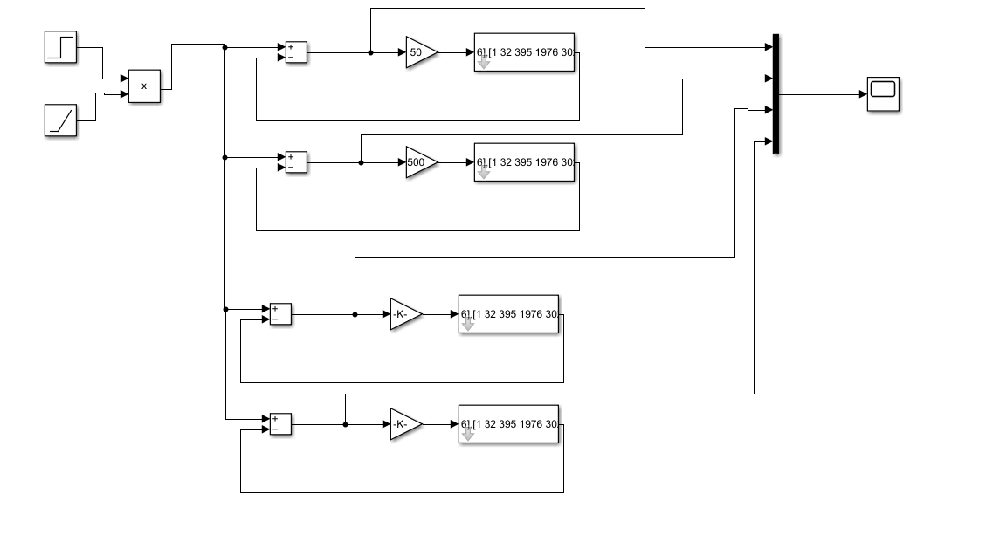

**Result:**

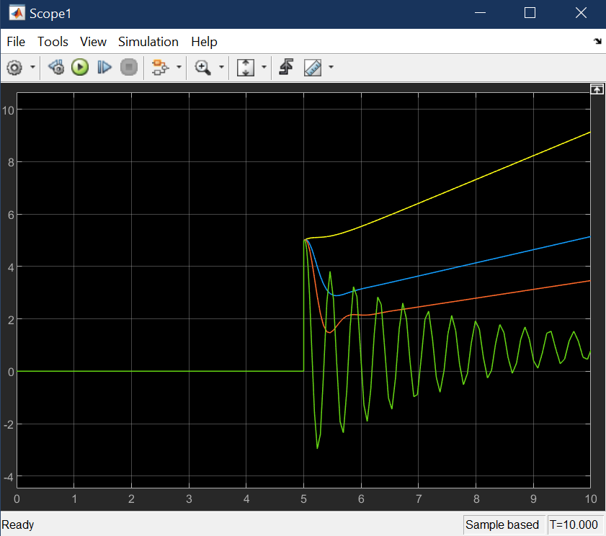

**Task3:**

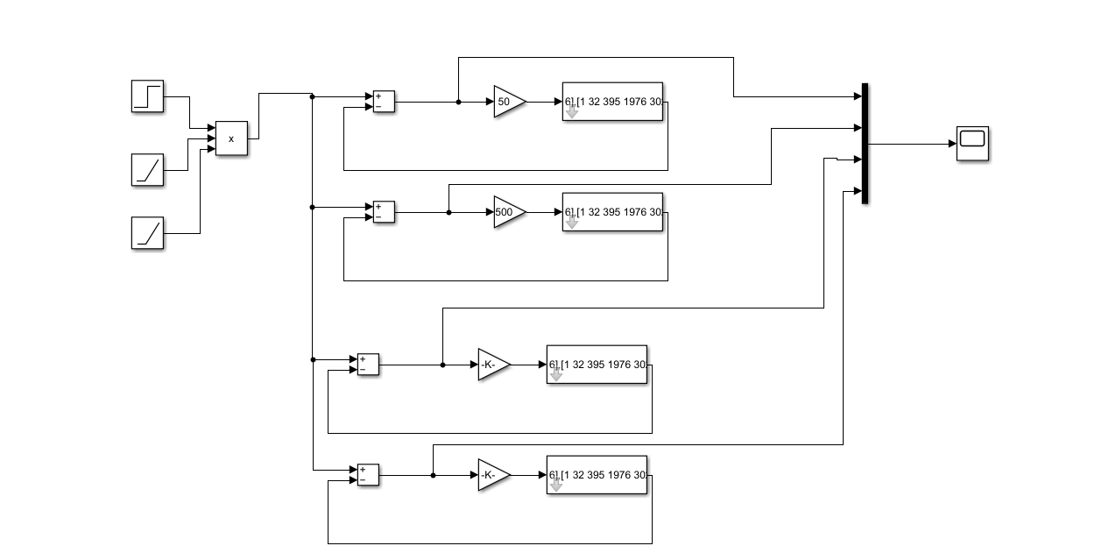

**Result:**

